
a
Company
Logotype

Cone Beam Computed Tomography- Report



Porur Dental X-rays & CBCT

Patient Name : Mr. Magesh | Date of Report : 15.11.2025
Age/ Gender : 25 years/ Male | Region of Interest : CBCT Full Skull
Referring doctor: Dr. Suchitra Mohan | Indication : Orthodontic evaluation
Clinical Notes: Nil
PATIENT INFORMATION

CBCT- Full Skull provided
CBCT – IMAGE DETAILS

RADIOGRAPHIC INTERPRETATION

- No of teeth present in the maxillary and mandibular arch: 26; Completely missing crown and root portion in relation to: 12, 18, 22, 28, 38, 48.
- The maxillary and mandibular alveolar ridge are present with normal trabecular pattern.
- Interdental spacing present between 11, 13, 21, 23.
- The mandibular teeth appear to be retroclined.
- Deviated nasal septum towards the right side is evident; the right nasal passage appears narrow when compared to the left side.
- Maxillary Arch Length : 104.9 mm
- Mandibular Arch Length: 104.5 mm

RADIOGRAPHIC IMPRESSION

- Malocclusion
- Nasal septum deviation.

Kindly correlate with clinical findings


IMAGES FOR REFERENCE

RECONSTRUCTED PANORAMIC VIEW
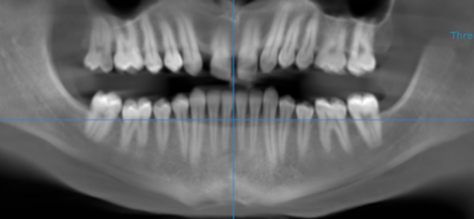

3-DIMENSIONAL VIEW
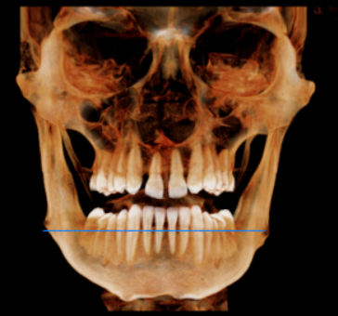

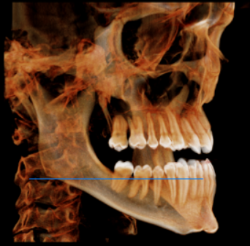
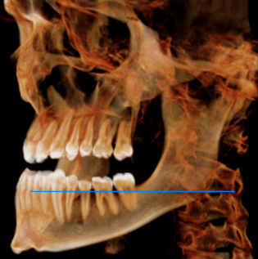

CORONAL VIEW
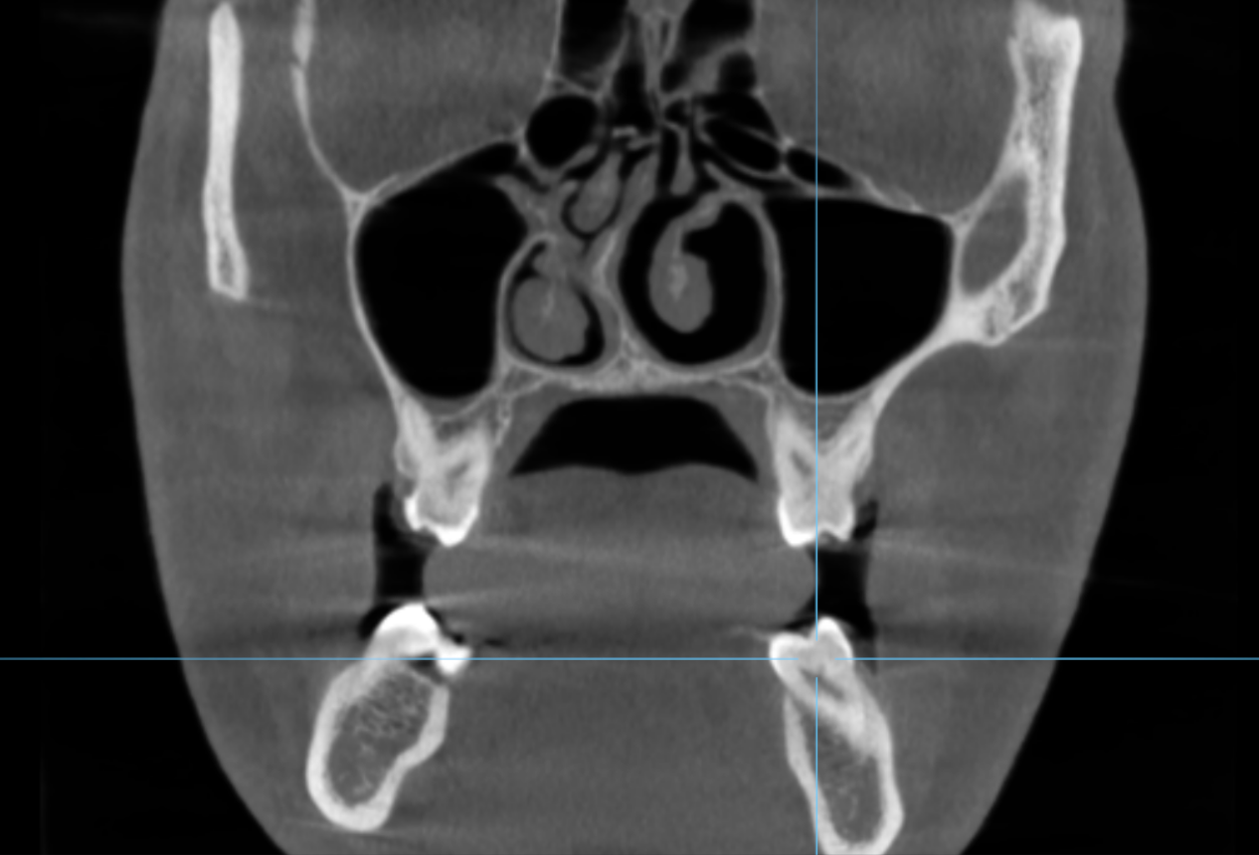

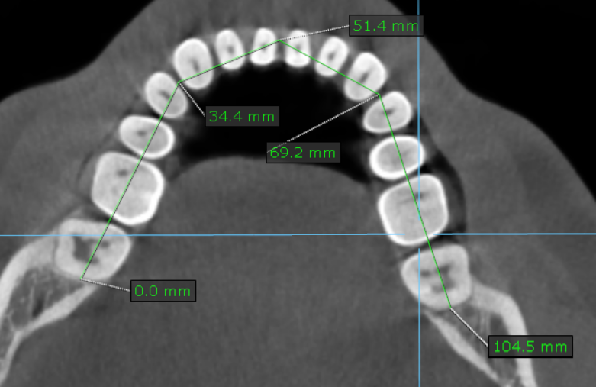
AXIAL VIEW
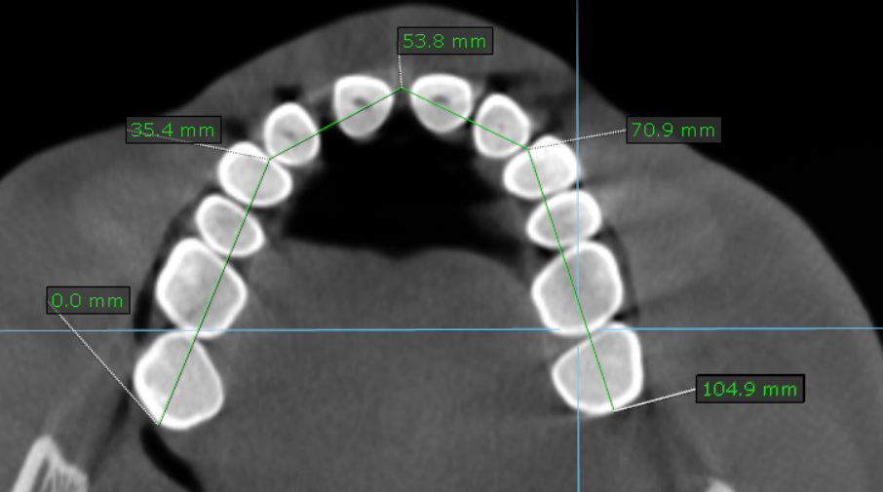

*** End of report ****

